Ideation Phase
Brainstorm & Idea Prioritization Template

Date | 25 September 2026
Team ID | SWTID-2026-9989
Project Name | Script-Controlled ACL – Restrict Record Access Based on Field Value
Maximum Marks | 4 Marks

Brainstorm & Idea Prioritization Template:
Brainstorming provides a free and open environment that encourages everyone within a team to participate in the creative thinking process that leads to problem solving. Prioritizing volume over value, out-of-the-box ideas are welcome and built upon, and all participants are encouraged to collaborate, helping each other develop a rich amount of creative solutions.
Use this template in your own brainstorming sessions so your team can unleash their imagination and start shaping concepts even if you're not sitting in the same room.
Reference: https://www.mural.co/templates/brainstorm-and-idea-prioritization
Step-1: Team Gathering, Collaboration and Select the Problem Statement
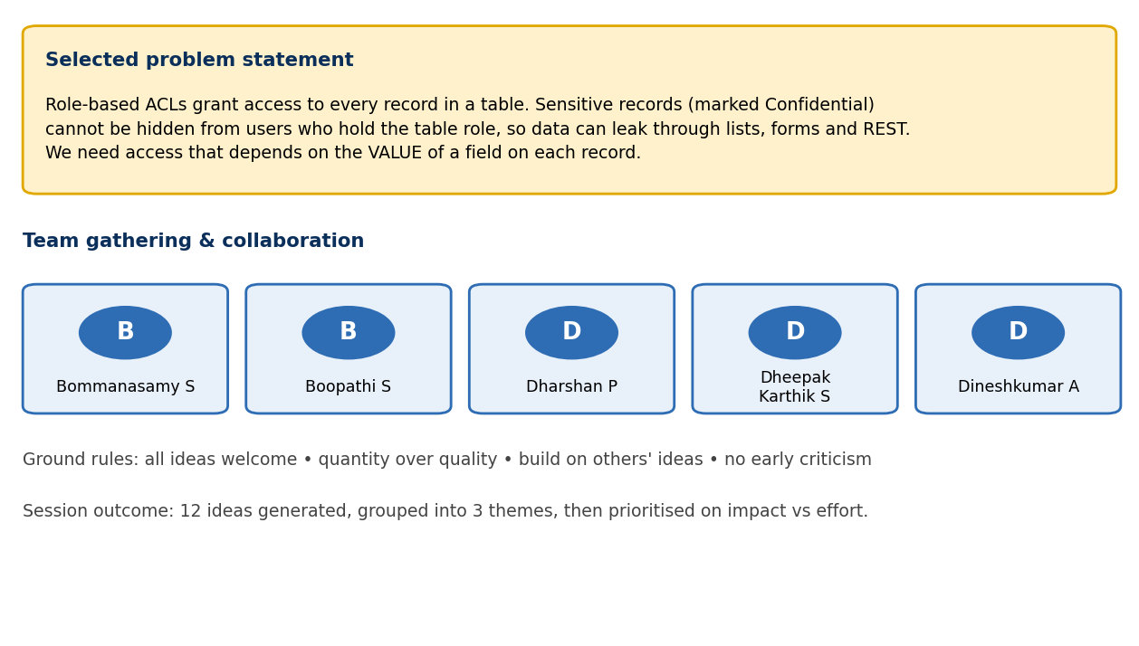

Step-2: Brainstorm, Idea Listing and Grouping
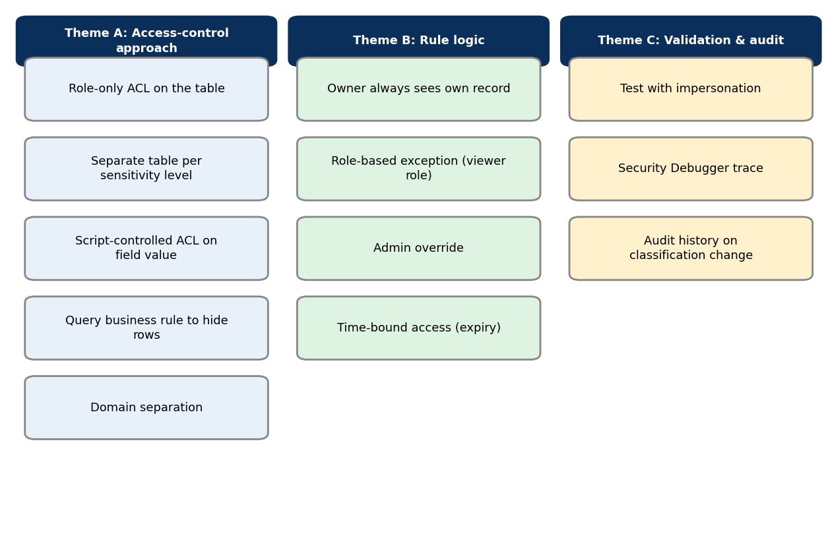

Step-3: Idea Prioritization
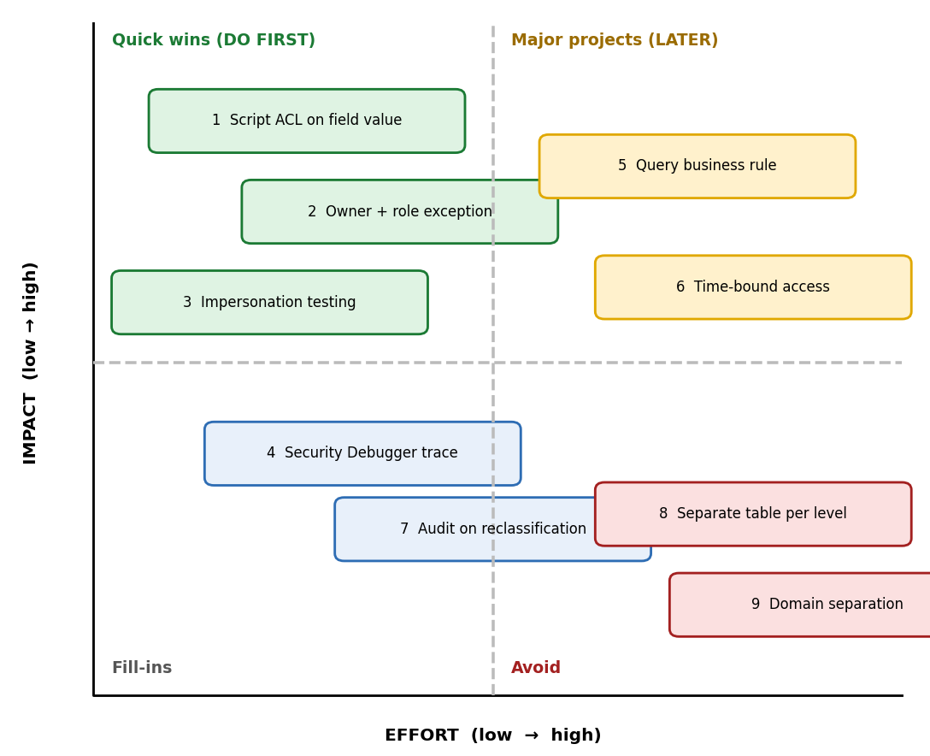
Outcome: the team selected a script-controlled ACL that reads the Classification field of each record (idea 1), with owner / viewer-role exceptions (idea 2), verified using impersonation and Security Debugger (ideas 3 and 4).

